Схема базы данных
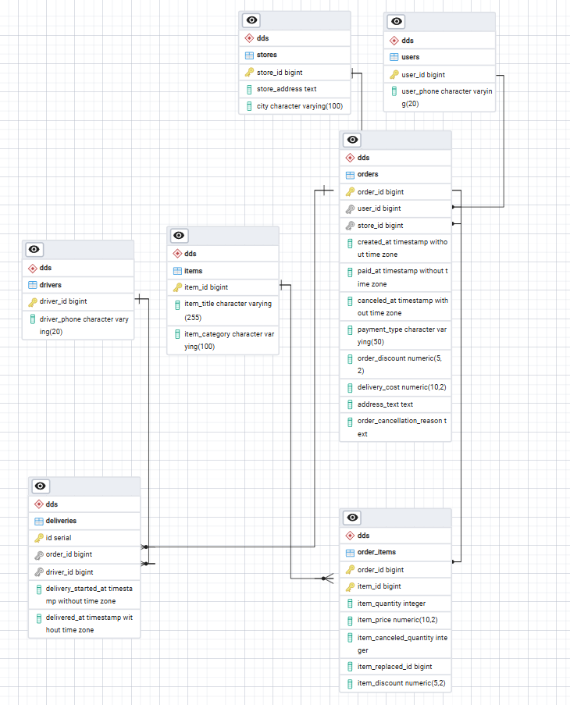

(В коде все сразу под 3NF готовилось, описание шагов относится к проектированию структуры БД)
Приведение к 1NF:
- Адреса частично были приведены к 1NF. 0NF остался для колонок с адресом. В таблице store остался исходный адрес, но появился выделен город. В таблице orders исходный адрес.
- Для каждой строки определен составной первичный ключ (order_id, item_id), который уникально идентифицирует строку (один товар в одном заказе).

Приведение к 2NF:
После 1NF был составной ключ для заказов, но часть атрибутов зависела от только от одного ключа
- Атрибуты item_title, item_category перенесены в новую таблицу items с ключом item_id.
- Атрибуты заказа (created_at, paid_at, payment_type и т.д.) перенесены в новую таблицу dds.orders с ключом order_id.
- В исходной таблице остались только атрибуты, зависящие именно от связки заказ+товар это и стало таблицей dds.order_items.
Приведение к 3NF:
Поля (user_id, store_id, driver_id) стал первичным ключом своей отдельной таблицы, а все зависящие от него атрибуты были туда перенесены:
- user_id: user_phone стали новой таблицей dds.users.
- store_id: store_address, city стали новой таблицей dds.stores.
- driver_id: driver_phone стали новой таблицей dds.drivers.

В таблице dds.orders остались только ссылки (Foreign Keys) user_id и store_id. Таблица dds.deliveries была выделена отдельно, так как один заказ мог обслуживаться несколькими курьерами.

Скрипты для создания таблиц
CREATE SCHEMA IF NOT EXISTS raw;
CREATE SCHEMA IF NOT EXISTS dds;
CREATE SCHEMA IF NOT EXISTS marts;

-- таблицы в 3nf
CREATE TABLE IF NOT EXISTS dds.users (
user_id BIGINT PRIMARY KEY,
user_phone VARCHAR(20)
);

CREATE TABLE IF NOT EXISTS dds.stores (
store_id BIGINT PRIMARY KEY,
store_address TEXT,
city VARCHAR(100)
);

CREATE TABLE IF NOT EXISTS dds.drivers (
driver_id BIGINT PRIMARY KEY,
driver_phone VARCHAR(20)
);

CREATE TABLE IF NOT EXISTS dds.items (
item_id BIGINT PRIMARY KEY,
item_title VARCHAR(255),
item_category VARCHAR(100)
);

CREATE TABLE IF NOT EXISTS dds.orders (
order_id BIGINT PRIMARY KEY,
user_id BIGINT REFERENCES dds.users(user_id),
store_id BIGINT REFERENCES dds.stores(store_id),
created_at TIMESTAMP,
paid_at TIMESTAMP,
canceled_at TIMESTAMP,
payment_type VARCHAR(50),
order_discount NUMERIC(5,2),
delivery_cost NUMERIC(10,2),
address_text TEXT,
order_cancellation_reason TEXT
);

CREATE TABLE IF NOT EXISTS dds.order_items (
order_id BIGINT REFERENCES dds.orders(order_id),
item_id BIGINT REFERENCES dds.items(item_id),
item_quantity INT,
item_price NUMERIC(10,2),
item_canceled_quantity INT,
item_replaced_id BIGINT,
item_discount NUMERIC(5,2),
PRIMARY KEY (order_id, item_id)
);

CREATE TABLE IF NOT EXISTS dds.deliveries (
id SERIAL PRIMARY KEY,
order_id BIGINT REFERENCES dds.orders(order_id),
driver_id BIGINT REFERENCES dds.drivers(driver_id),
delivery_started_at TIMESTAMP,
delivered_at TIMESTAMP
);

-- витрины
CREATE TABLE IF NOT EXISTS marts.fct_orders (
report_year INT, report_month INT, report_day INT,
city VARCHAR(100), store_id BIGINT,
turnover NUMERIC(15,2), revenue NUMERIC(15,2), profit NUMERIC(15,2),
total_orders INT, delivered_orders INT, canceled_orders INT,
post_delivery_cancels INT, service_error_cancels INT,
unique_buyers INT, avg_check NUMERIC(10,2),
orders_per_buyer NUMERIC(10,2), revenue_per_buyer NUMERIC(15,2),
courier_changes INT, active_couriers INT,
PRIMARY KEY (report_year, report_month, report_day, city, store_id)
);

CREATE TABLE IF NOT EXISTS marts.fct_items (
report_year INT, report_month INT, report_day INT,
city VARCHAR(100), store_id BIGINT, item_category VARCHAR(100), item_id BIGINT,
item_turnover NUMERIC(15,2), ordered_qty INT, canceled_qty INT,
orders_with_item INT, orders_with_cancel INT,
PRIMARY KEY (report_year, report_month, report_day, city, store_id, item_category, item_id)
);

Скрипты для заполнения таблиц:
"""
-- 1. Справочник: Users
INSERT INTO dds.users (user_id, user_phone)
SELECT CAST(user_id AS BIGINT), MAX(CAST(user_phone AS TEXT))
FROM raw.raw_deliveries WHERE user_id IS NOT NULL
GROUP BY CAST(user_id AS BIGINT)

ON CONFLICT (user_id) DO UPDATE SET
user_phone = EXCLUDED.user_phone;

-- 2. Справочник: Stores
INSERT INTO dds.stores (store_id, store_address, city)
SELECT CAST(store_id AS BIGINT), MAX(CAST(store_address AS TEXT)), MAX(split_part(CAST(store_address AS TEXT), ',', 2))
FROM raw.raw_deliveries WHERE store_id IS NOT NULL
GROUP BY CAST(store_id AS BIGINT)

ON CONFLICT (store_id) DO UPDATE SET
store_address = EXCLUDED.store_address,
city = EXCLUDED.city;

-- 3. Справочник: Drivers
INSERT INTO dds.drivers (driver_id, driver_phone)
SELECT CAST(driver_id AS BIGINT), MAX(CAST(driver_phone AS TEXT))
FROM raw.raw_deliveries WHERE driver_id IS NOT NULL
GROUP BY CAST(driver_id AS BIGINT)

ON CONFLICT (driver_id) DO UPDATE SET
driver_phone = EXCLUDED.driver_phone;

-- 4. Справочник: Items
INSERT INTO dds.items (item_id, item_title, item_category)
SELECT CAST(item_id AS BIGINT), MAX(CAST(item_title AS TEXT)), MAX(CAST(item_category AS TEXT))
FROM raw.raw_deliveries WHERE item_id IS NOT NULL
GROUP BY CAST(item_id AS BIGINT)

ON CONFLICT (item_id) DO UPDATE SET
item_title = EXCLUDED.item_title,
item_category = EXCLUDED.item_category;

-- 5. Транзакции: Orders
INSERT INTO dds.orders (order_id, user_id, store_id, created_at, paid_at, canceled_at, payment_type, order_discount, delivery_cost, address_text, order_cancellation_reason)
SELECT
CAST(order_id AS BIGINT),
MAX(CAST(user_id AS BIGINT)),
MAX(CAST(store_id AS BIGINT)),
MAX(CAST(created_at AS TIMESTAMP)),
MAX(CAST(paid_at AS TIMESTAMP)),
MAX(CAST(canceled_at AS TIMESTAMP)),
MAX(CAST(payment_type AS TEXT)),
MAX(CAST(order_discount AS NUMERIC)),
MAX(CAST(delivery_cost AS NUMERIC)),
MAX(CAST(address_text AS TEXT)),
MAX(CAST(order_cancellation_reason AS TEXT))
FROM raw.raw_deliveries
GROUP BY CAST(order_id AS BIGINT)

ON CONFLICT (order_id) DO UPDATE SET
user_id = EXCLUDED.user_id,
store_id = EXCLUDED.store_id,
created_at = EXCLUDED.created_at,
paid_at = EXCLUDED.paid_at,
canceled_at = EXCLUDED.canceled_at,
payment_type = EXCLUDED.payment_type,
order_discount = EXCLUDED.order_discount,
delivery_cost = EXCLUDED.delivery_cost,
address_text = EXCLUDED.address_text,
order_cancellation_reason = EXCLUDED.order_cancellation_reason;

-- 6. Транзакции: Order Items
INSERT INTO dds.order_items (order_id, item_id, item_quantity, item_price, item_canceled_quantity, item_replaced_id, item_discount)
SELECT
CAST(order_id AS BIGINT),
CAST(item_id AS BIGINT),
MAX(CAST(item_quantity AS INT)),
MAX(CAST(item_price AS NUMERIC(10,2))),
MAX(CAST(item_canceled_quantity AS INT)),
MAX(CAST(CAST(item_replaced_id AS FLOAT) AS BIGINT)),
MAX(CAST(item_discount AS NUMERIC(5,2)))
FROM raw.raw_deliveries
GROUP BY CAST(order_id AS BIGINT), CAST(item_id AS BIGINT)

ON CONFLICT (order_id, item_id) DO UPDATE SET
item_quantity = EXCLUDED.item_quantity,
item_price = EXCLUDED.item_price,
item_canceled_quantity = EXCLUDED.item_canceled_quantity,
item_replaced_id = EXCLUDED.item_replaced_id,
item_discount = EXCLUDED.item_discount;

-- 7. Факты доставок (здесь PK просто serial, поэтому так добавляем новые записи)
DELETE FROM dds.deliveries WHERE order_id IN (SELECT DISTINCT CAST(order_id AS BIGINT) FROM raw.raw_deliveries);

INSERT INTO dds.deliveries (order_id, driver_id, delivery_started_at, delivered_at)
SELECT
CAST(order_id AS BIGINT),
CAST(driver_id AS BIGINT),
MAX(CAST(delivery_started_at AS TIMESTAMP)),
MAX(CAST(delivered_at AS TIMESTAMP))
FROM raw.raw_deliveries
WHERE driver_id IS NOT NULL
GROUP BY CAST(order_id AS BIGINT), CAST(driver_id AS BIGINT);
"""

